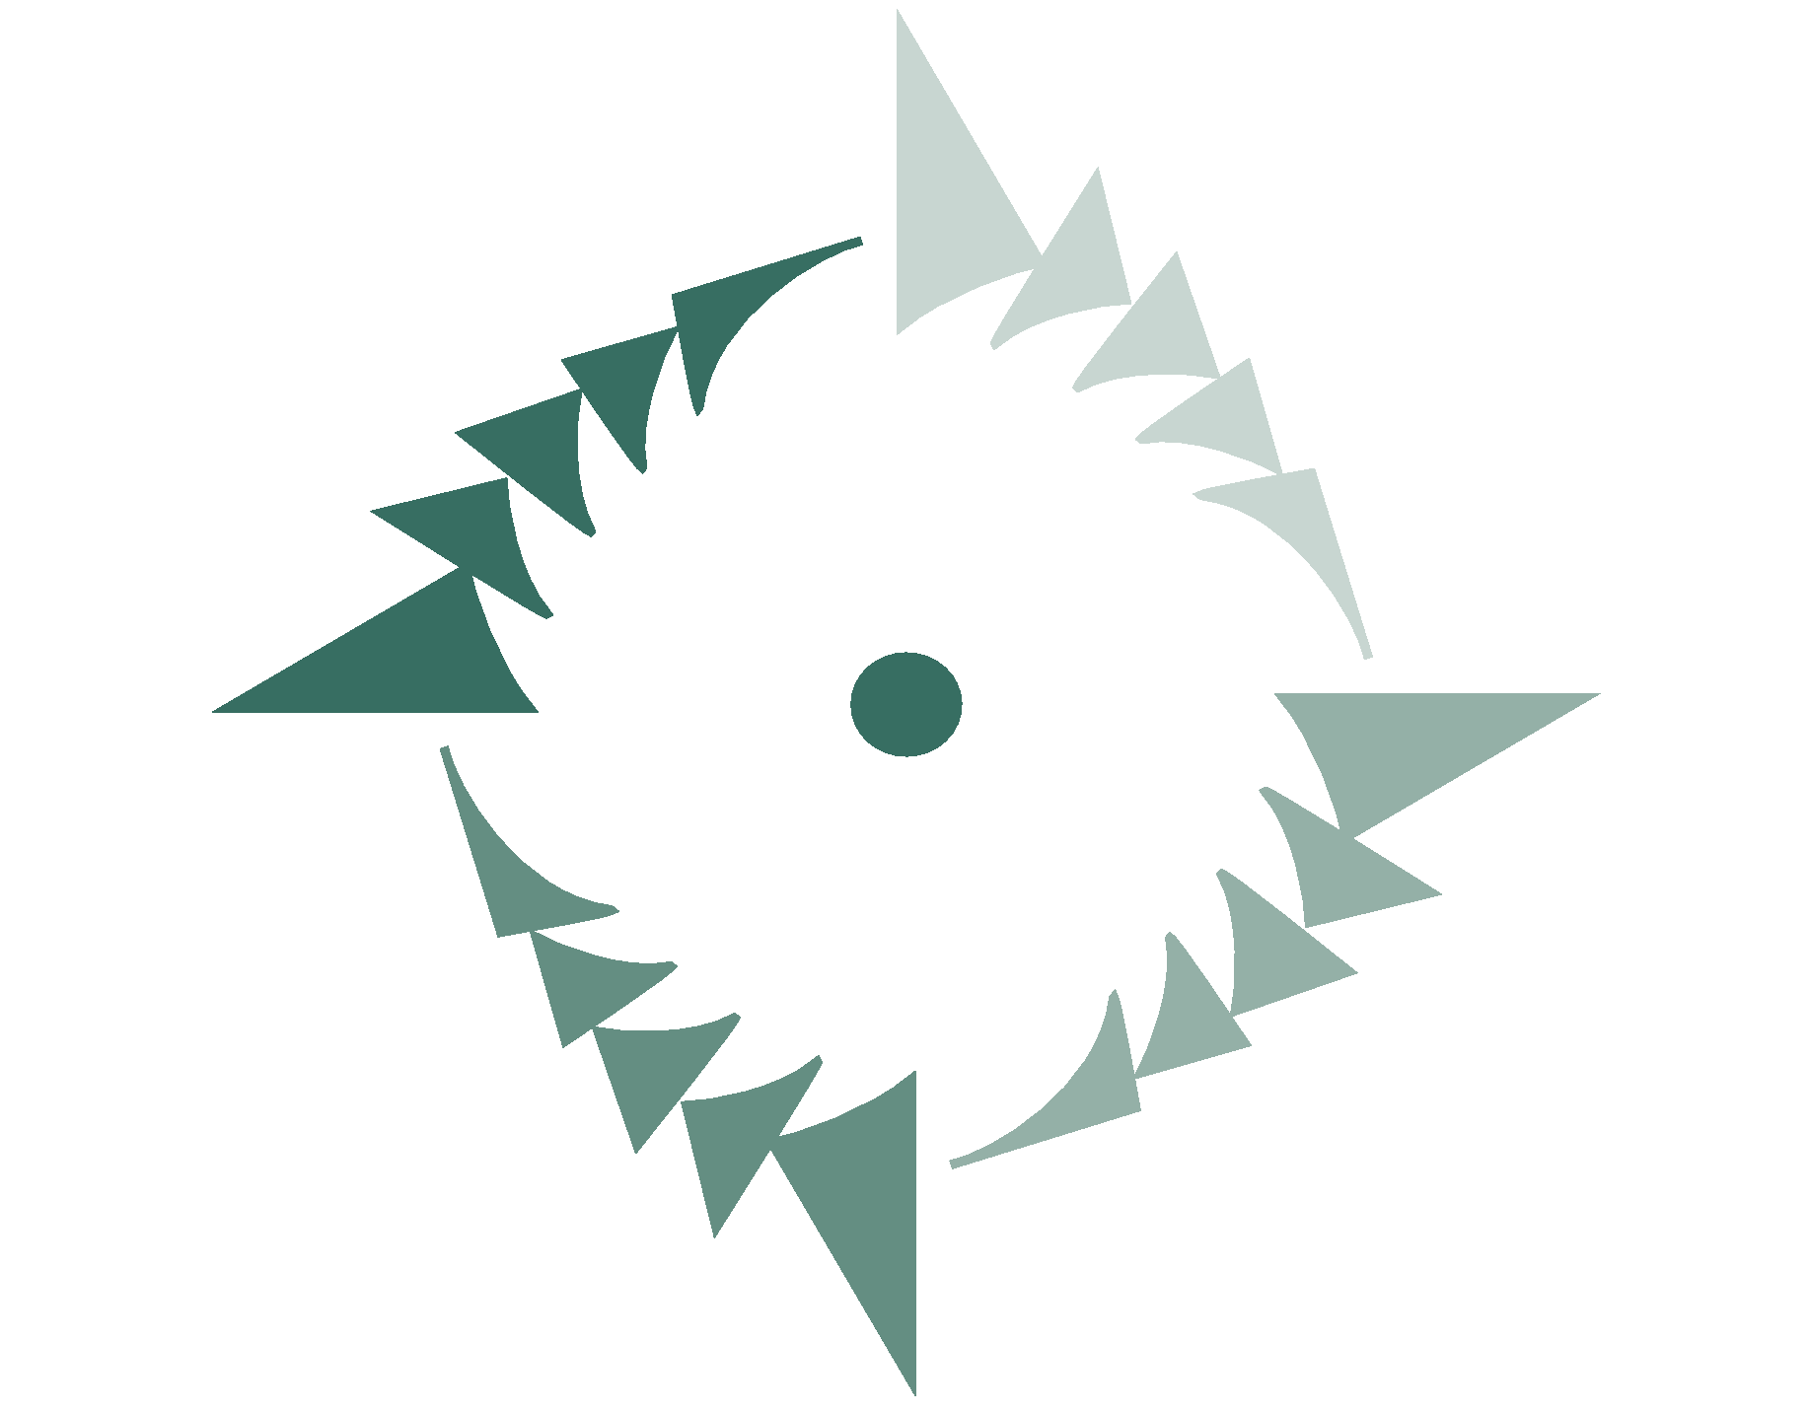
NorSask Forest Products

Job Description

Position Title: Controls/Optimization Technician

Reports To: Operations Manager

Function/Purpose:

Reporting to the Operations Manager – Working to maximize profit, lumber recovery and product quality by optimizing production, product flow and grade standards to meet current market demands and customer requirements.

Key Responsibilities:

- Assist in developing and achieving targets in safety, quality, cost, delivery and employee engagement
- Assist in Capital Project installations and commissioning
- Support continuous improvement initiatives across the site for safety, quality, and production
- Work closely with supervisors to ensure quality and production standards are understood and achieved
- Engage in regular monitoring and tracking of machine center performance
- Support quality control processes across the site as required
- PLC programming installation/servicing/troubleshooting
- Support automation initiatives
- Attend applicable training courses & meetings to enhance job skills and knowledge

Quality:

- A strong commitment to safety
- Excellent organizational, interpersonal, analytical and problem solving skills
- Strong computer skills
- Strong mechanical aptitude
- Creative thinker
- Team player
- Results focused
- Committed to learning and skill development

Education and Training Requirements

- Post-secondary education in a relevant field: electrical, information technology, instrumentation, electronics engineering, programming, controls and automation design.
- Log Scaling and Grading certification would be an asset
- Work experience in a milling/industrial envirionment environment

I certify that the above information describes the primary responsibility assigned to me, and that I have been provided with a copy of this job description.

Employee Signature Print Name Date

I certify that the above information accurately describes the responsibilities assigned to this position.

